Learn how to build Sp-D2! Learn about each of the Droids! And how you can become a member! All that and more in this semester’s issue of the Ao-D2 magazine!

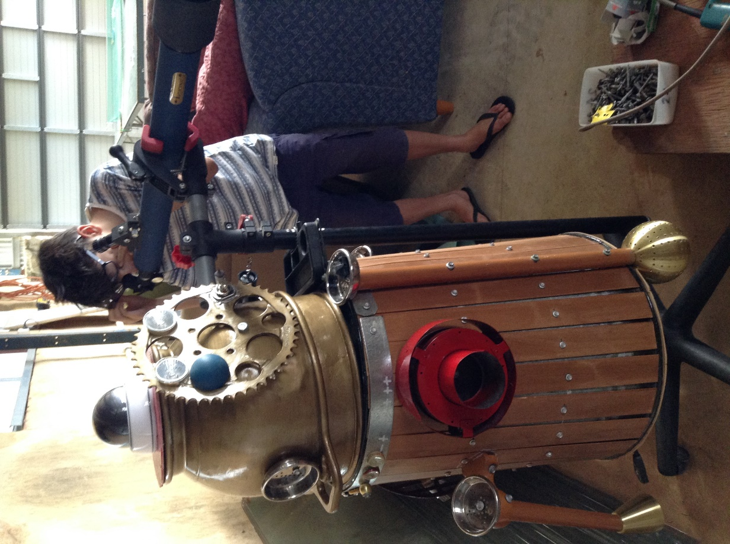

Our Websites!

Check us out at:

<http://astromech.net/forums/member.php?31412-Ao-D2>

<https://twitter.com/DroidsAlliance>

Email me at

[arbuckle.liam@gmail.com](mailto:arbuckle.liam@gmail.com)

[allianceofdroidsla@gmail.com](mailto:allianceofdroidsla@gmail.com)

# ~~Sp-D2 Build Log~~

[Pick the date]

Alliance of droids

Sp-D2

Sp-8

«www.astromech.net»

Introduction

So, where to begin? I guess I should start with the dream. Not the sleep kind, but the achievement kind of dream. For ages now I have been wanting to build my very own R2-D2. I joined the Astromech Builders Club in November 2014 and eventually I decided to build a steampunk droid – Sp-D2. This droid will eventually be fully motorized, have a display cabinet, and even its own primitive vending machine. I chose the name for Sp-D2 myself.

So I thought about it a bit more, and realized that I would need someone to help me build him. I ruled out dad because, after all, he is only my dad and not a master builder. So then I had a great moment of ideas. Since we were going to Melbourne this December, I thought I could build him with my uncle. He built his own house from scratch in the mountains of Tawonga, and I knew he could help me.

So we were all sorted. I had enough time to get my ass into gear and contact Ian (my uncle). I had enough time to ask around of [www.astromech.net](http://www.astromech.net) and finally enough time to work out my budget.

Bibliography

Jesus Christ – there are bloody ants on my computer.

So anyway, I spent two months looking up on the Net (mainly while I was at school, because Net Control 2 wasn’t completely installed yet and my school has the best internet there is. Wi-Fi is magic and should be worshipped.

I bookmarked EVERYTHING that I could find on the Net that could help me in my search. After two long, hard months of research I had my shortlist ready. Here we go:

* How to Build R2-D2 low cost full size scratch build
* Steampunk R2-D2 by the CHOCOLATIST

Day 1 – 4th January 2016

As you can see from the photos that I have uploaded, the Tuesday we spent working on the project was mainly finding the bin that we could start with. We also cut the wood into strips 2 inches/ 5 cm wide and 55 cm high. Since the bin was slightly wider at the bottom than at the top, when we used the screw gun to put the screw in we had to be careful not to split the wood. The average circumference was 163 cm – 65.2 inches.

We then spray-painted the top and the rims of the trash can with black spray paint. Funnily enough, a lot of books say that R2-D2 looks like a fancy trash can for a non-star wars fan!

* The wood we used was probably from blinds – yeah, the blinds you might have in your house.

Day 2 – 5th January 2016

The first photo for this day was the possible heads we found in Ian’s shed. Jesus, he has a big shed. Anyway, we ended up going with the bigger one and painting it gold to match the STEAMPUNK theme.

This photo is showing me and Ian (well you can only see Ian in the photo, but who gives a shit?) estimating a good spot to put our wood. We used our eyes to measure – short but SIMPLE!

About 14 wood planks later, we realized we would have to remove the wood again because of a very technical glitch – it was too big and the wood was starting to split. But we made even better progress as we literally trimmed them down to size.

This next photo shows Sp-D2 with a steel lining. This was supposed to keep the wood in place so it wouldn’t move around when we transported it back to Perth.

Day 3 – 6th january 2016

Today’s big accomplishment was getting the feet on. As you might be able to tell, we used light fittings from lamps that Ian’s had for years and stuck them on a 46° angle. We had a minor complication with the third leg – the second on the side (the damn screw went through the wood). Fortunately, we had a solution. We had an angle grinder that made short work of the screw.

Now there are angle grinders, and there are ANGLE GRINDERS. Ian’s was as big as they come, with a disk that could slice through metal like butter.

Shielding himself behind a piece of plywood, Ian set to work. But then, to Ian’s horror, the “blade caught, kicked back, went through the plywood, and into me.”

NO, not really! Ever seen Bizarre ER? Well, check this out:

The shoulders were – I’m not sure what they were. I’ll check with Ian. Anyway, we didn’t have to drill a hole through it, so it was fairly easy to attack.

Update: shoulder bits were from a commercial kitchen

Day 4 – 7th january 2016

Our next big thing today was fitting the base for Sp-D2 onto his bottom. As you might have guessed, a trash can turned upside down would still need a base.

We used a jig-saw to cut the circle out, and then we glued it onto the bottom of him. It would probably take the entire day to set, so we decided to leave the body alone for today.

Day 5 – 9th January 2016

Today was all about the tip. In the morning we cut up a bit of plywood to make a sort of top for the head so the security camera could balance on top. We also put the bottle caps (as badges) on the metal lining.

Afterwards we went to the tip. We had an amazing find with a working telescope and an awesome office chair that we could use to move Sp-D2 around.

Day 6 – 10th January 2016

All we really did today was mount the telescope on the body of Sp-D2. We unscrewed a huge stand that we could adjust the size, width and angle of, and we stuck that to Sp-D2.

------------------------------------------------------------------------------------------------------------------------------

Thanks for that. At last count, the blog had had 206 views and about 15 subscribers.

# How to become a member

Now to the next part: how can you become a member of the AoD? It is quite simple:

All you need to do is meet up with Liam or Nicholas via email or in person. There is an oath that you take, and we will tell you what to say.

Oath:

I understand that i will give my full responsibility to the cause and will do the very best to uphold our beliefs

I will not be ignorant to other members of the team and i also promise to choose my role and do my best to do my job

Sign: Liam Arbuckle

Current list of members:

|  |  |  |
| --- | --- | --- |
| Liam Arbuckle | DROID BUILDER  Leader  Founder  Scientist Opal | 23rd Dec. 2015 |
| Nicholas Antipas | Founder  Leader | 23rd Dec 2015 |
| Kathryn Antipas | Silver | 19th Dec 2015 |